Table S1: Metagenomics sequencing and assembly statistics

|  |  |  |  |
| --- | --- | --- | --- |
| Sample | wet | dry | flooded |
| Raw Reads | 116,592,642 | 114,970,478 | 113,353,812 |
| Clean Reads | 96,516,358 | 96,533,736 | 95,779,654 |
| Clean bases | 12,064,544,750 | 12,066,717,000 | 11,972,456,750 |
| Avg. read length (bp) | 125 | 125 | 125 |
| Total contig number | 126,606 | 128,688 | 137,073 |
| Total contig length(bp) | 170,078,229 | 172,706,972 | 194,040,904 |
| Max contig length(bp) | 104,130 | 114,486 | 105,251 |
| Min contig length(bp) | 500 | 500 | 500 |
| Average contig(bp) | 1,343 | 1,342 | 1,415 |
| Contigs N90 | 632 | 629 | 644 |
| Contigs N50 | 1,611 | 1,607 | 1751 |
| PEreads | 2833003 | 3293989 | 3619755 |
| PE | 5.87 | 6.82 | 7.56 |
| SEreads | 8491408 | 10107275 | 9857511 |
| SE | 8.8 | 10.47 | 10.29 |
| mapping_rate | 14.67 | 17.29 | 17.85 |

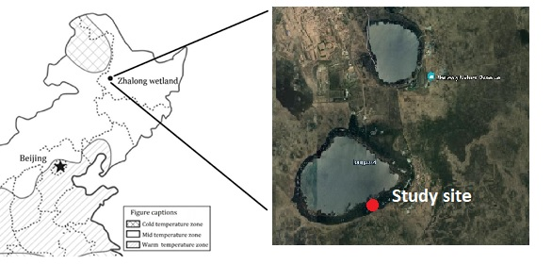

Fig. S1 Location of Zhalong wetland in northeastern China. The expanded image (Google) shows study site.

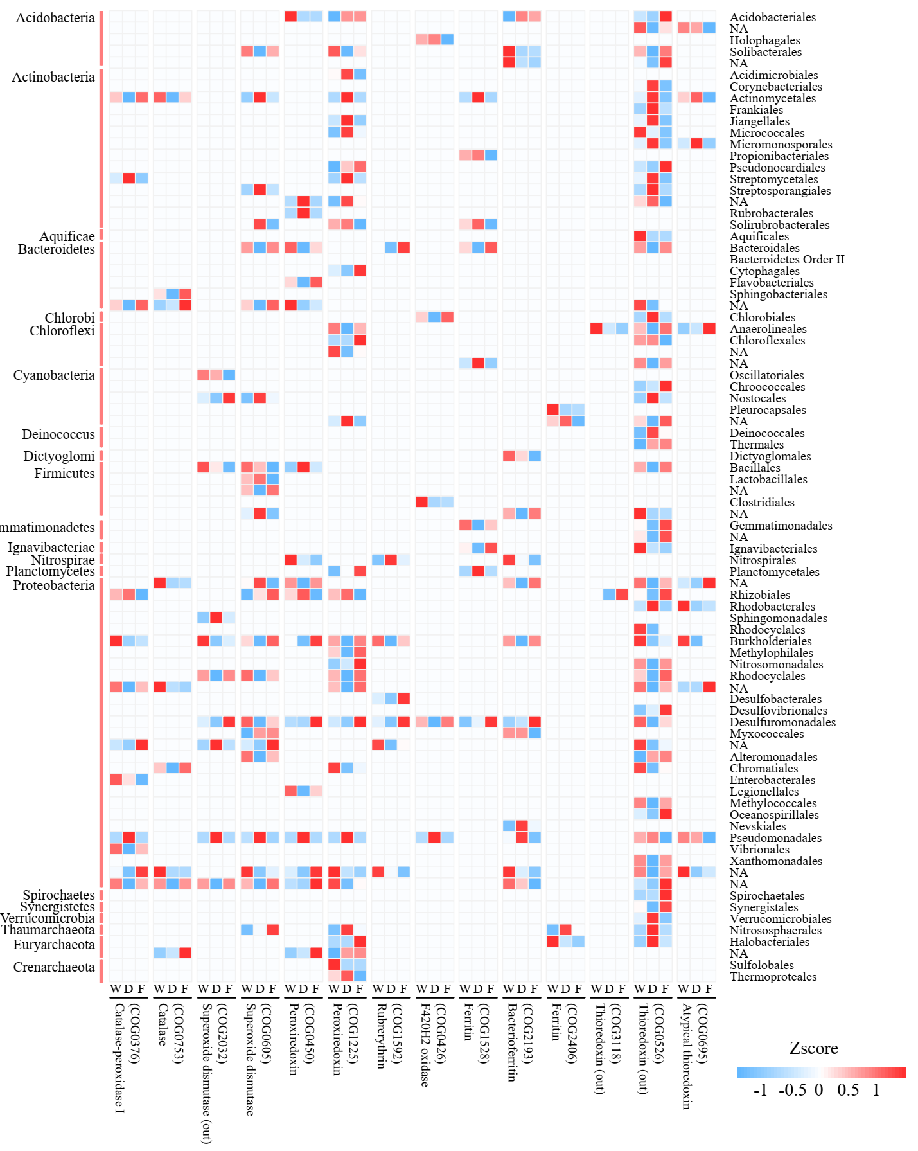Fig. S2. Taxonomic origins of the protein involved in anti-oxidation system during the three periods. Abbreviations: W, wet; D, dry; F, flooded.

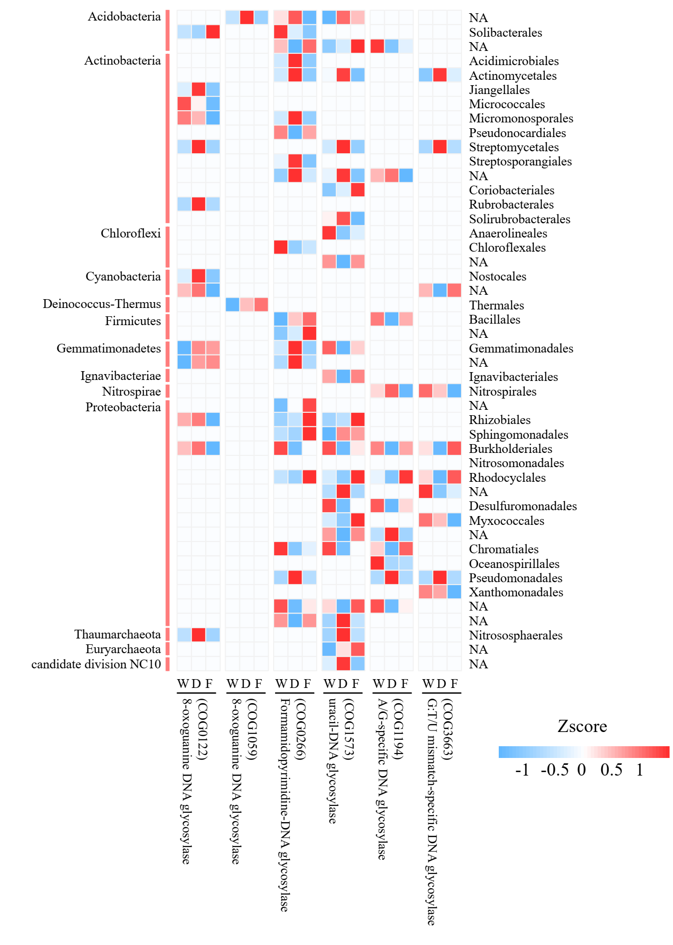

Fig. S3. Taxonomic origins of the protein involved in DNA base repair system (DNA glycolyase) during the three periods. Abbreviations: W, wet; D, dry; F, flooded.

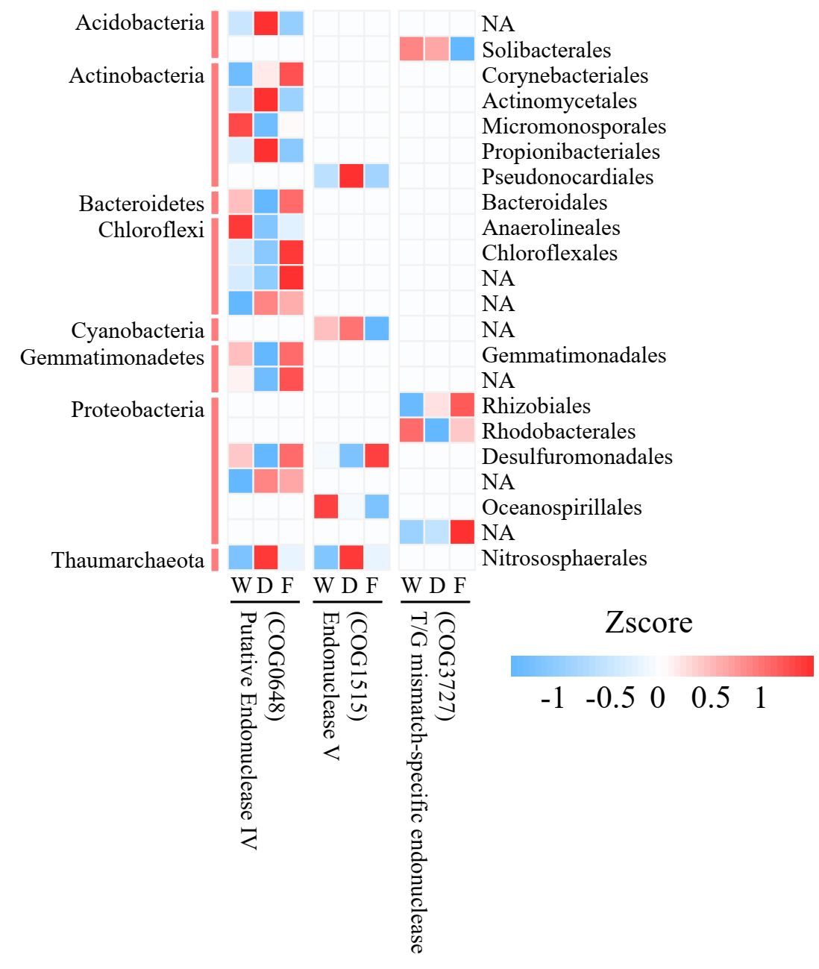

Fig. S4. Taxonomic origins of the protein involved in DNA base repair system (endonuclease) during the three periods. Abbreviations: W, wet; D, dry; F, flooded.

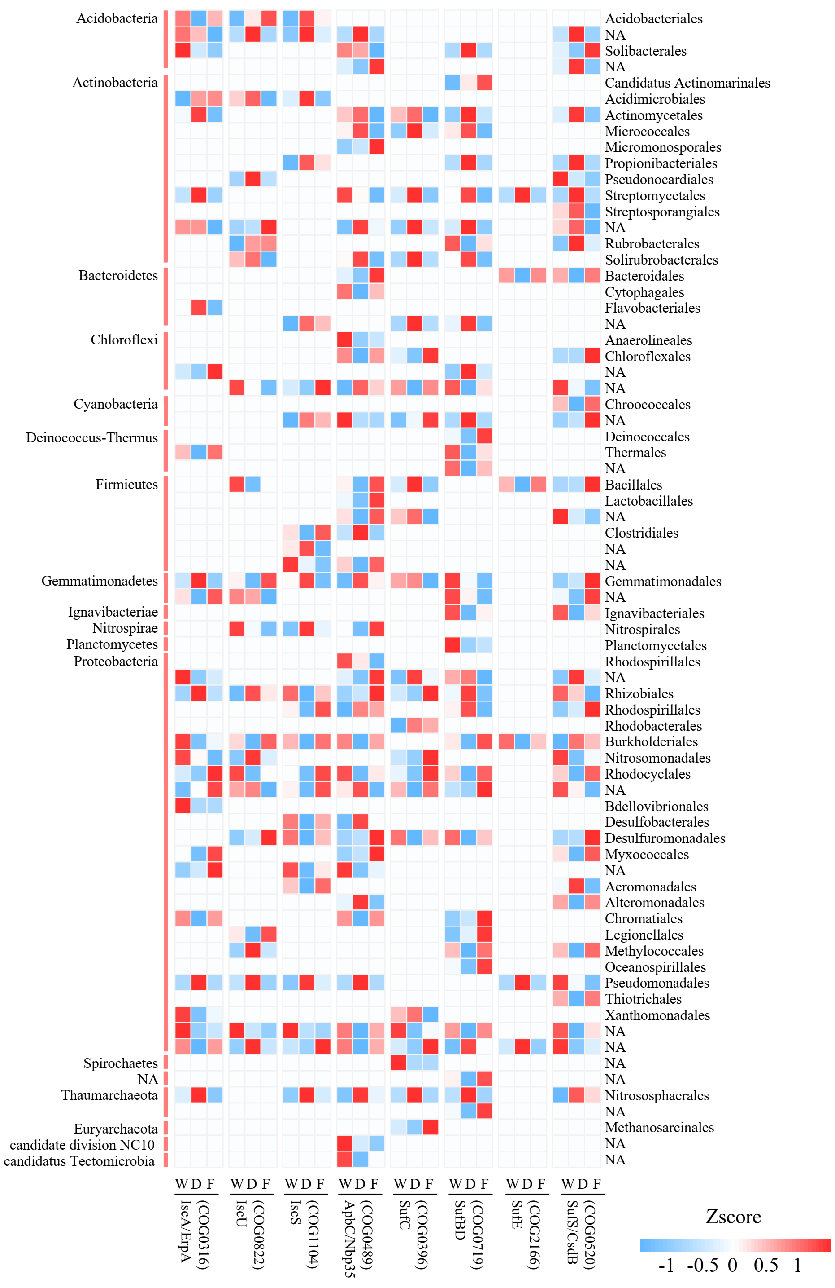Fig. S5. Taxonomic origins of the protein involved in iron-sulfur (FeS) clusters repair system during the three periods. Abbreviations: W, wet; D, dry; F, flooded.

Fig. S6. Taxonomic origins of the protein involved in protein repair system (SS recover) during the three periods. Abbreviations: W, wet; D, dry; F, flooded.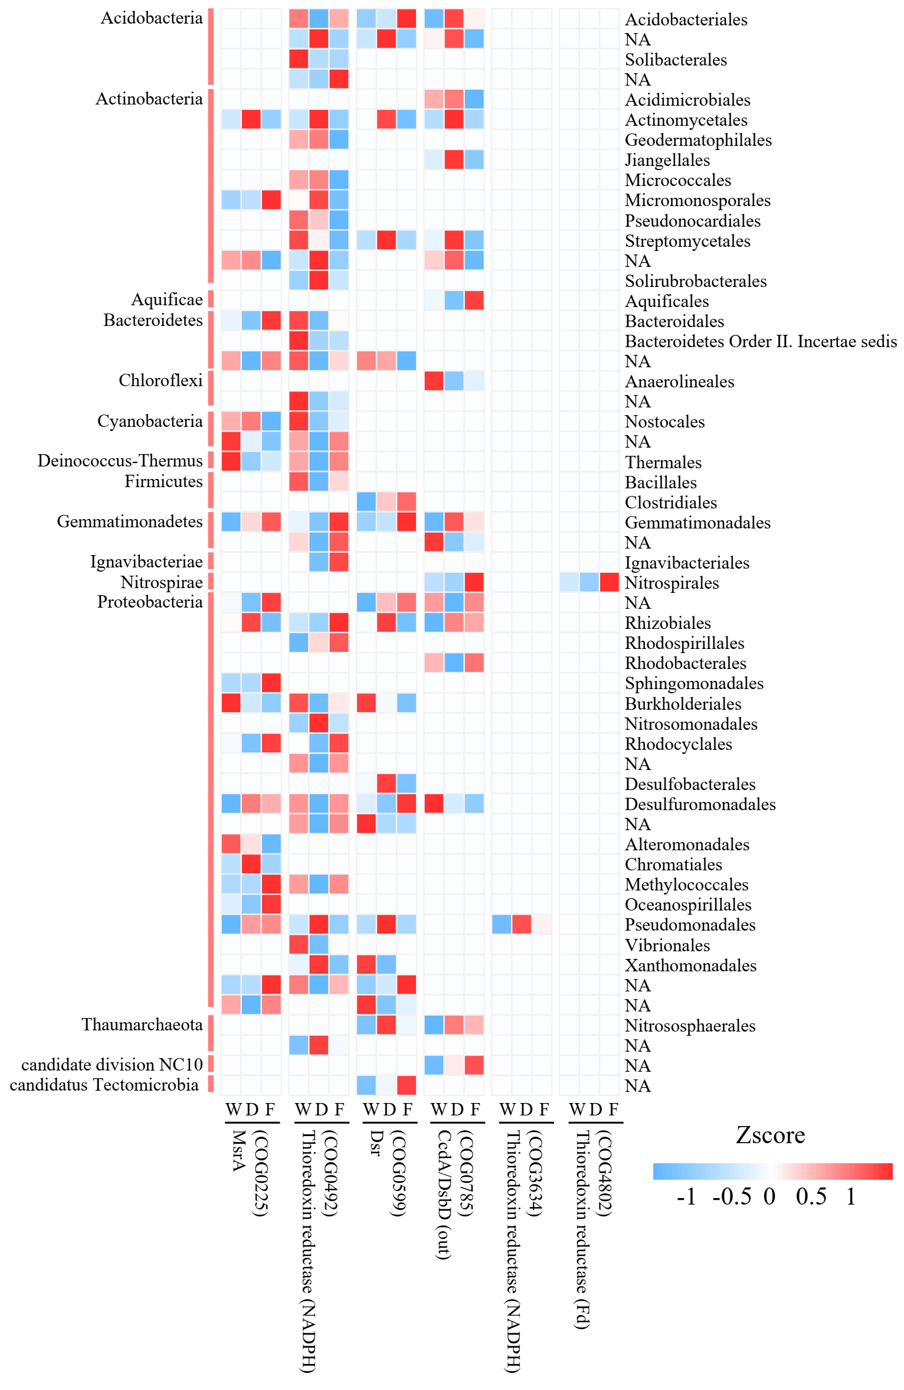

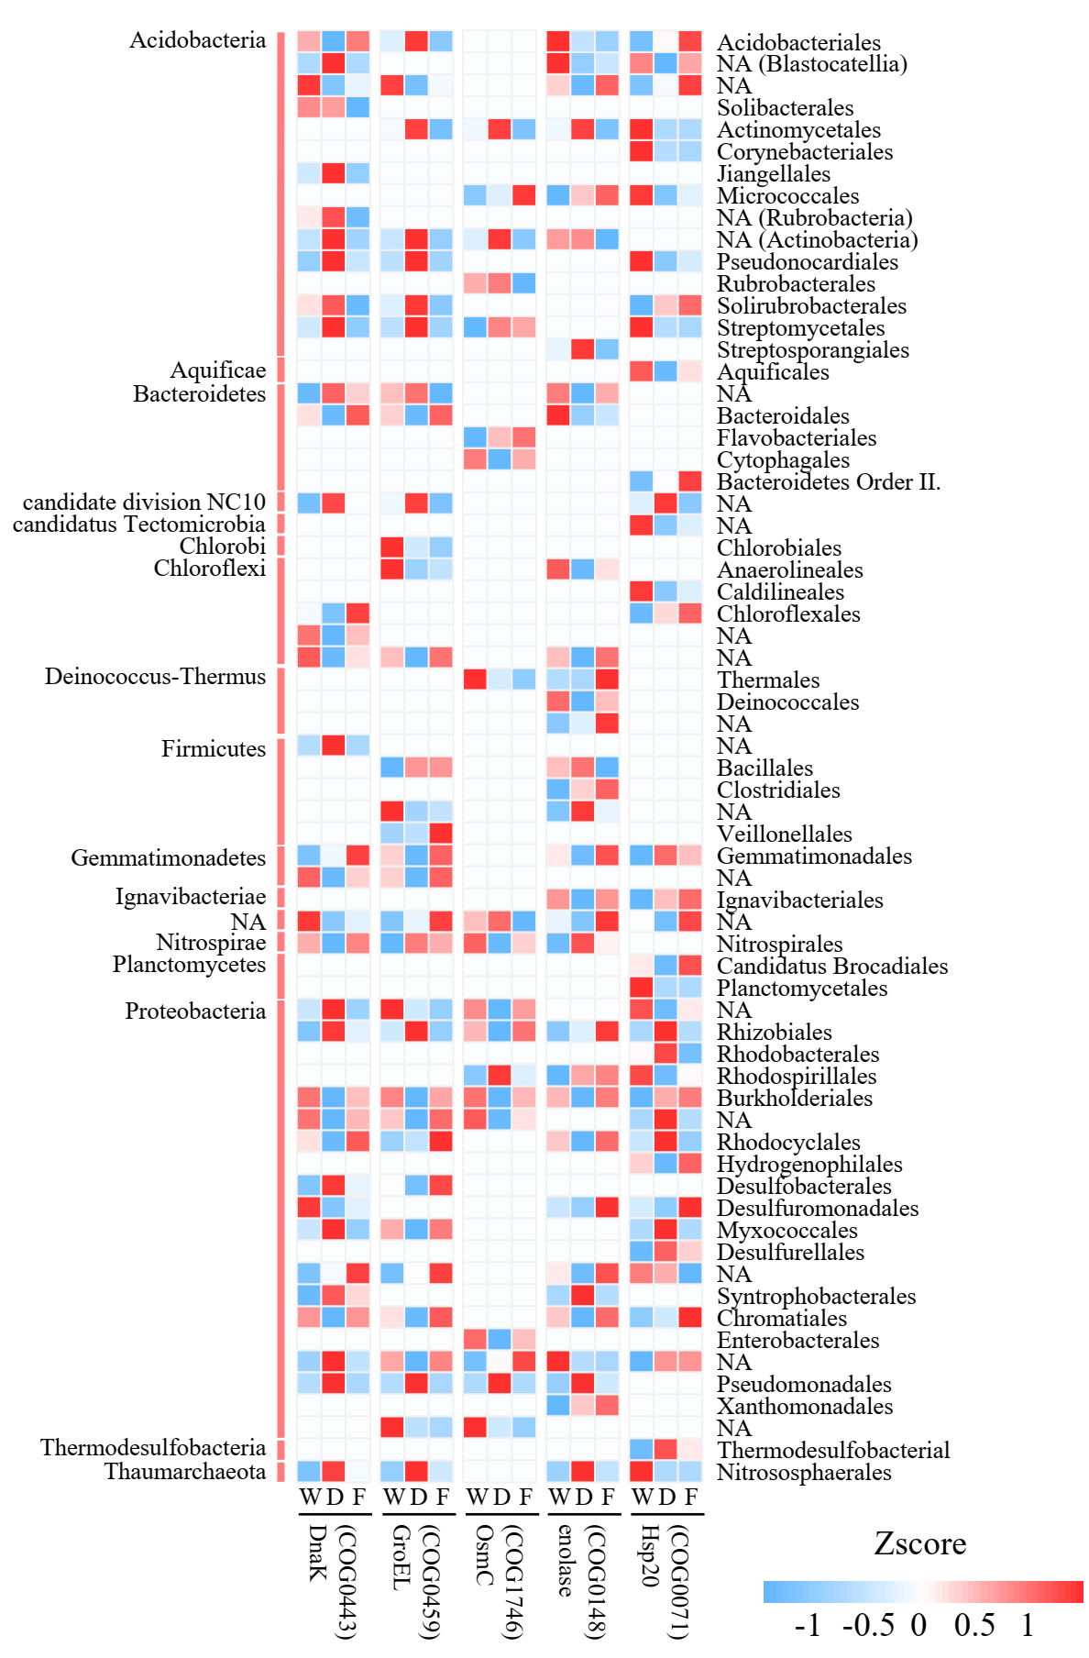Fig. S7. Taxonomic origins of the protein involved in VBNC system during the three periods. Abbreviations: W, wet; D, dry; F, flooded.